1. Open the ShoppingApp.EntityModelLibrary project created in the previous exercise
2. Use NuGet to add the **Microsoft.EntityFrameworkCore.Tools (version 5.0)** package to the project. This will provide the migration commands. Once the installation is done, the packages will appear in Solution Explorer:

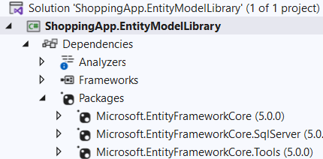

1. In Visual Studio, click on the Tools menu option, NuGet Package Manager- > Package Manager Console.
2. In the console, type the following command:

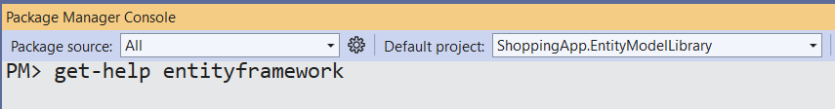

1. Understand the output of this command: observe the various options available for migrations.

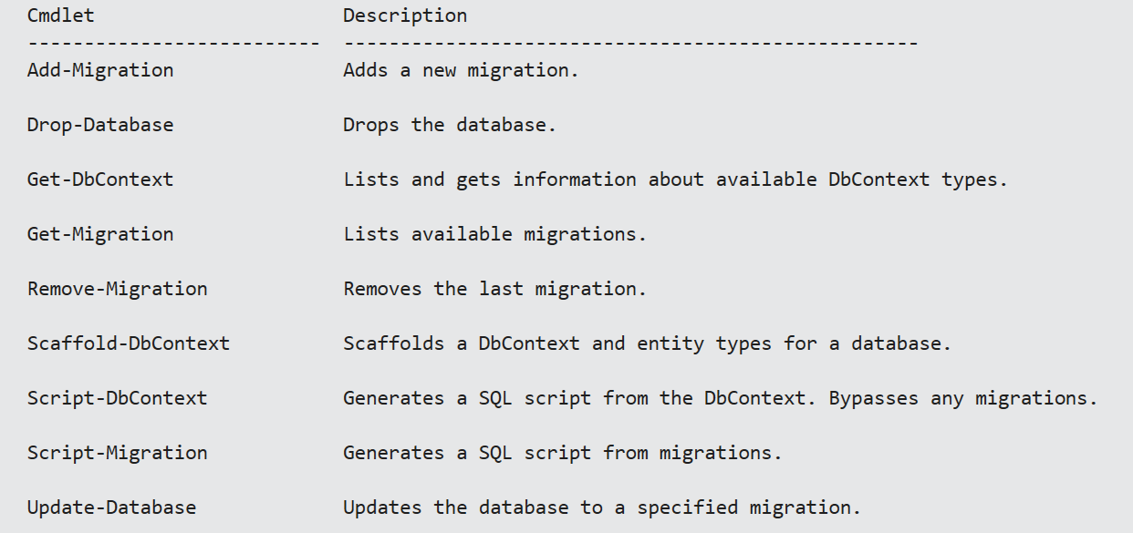

1. Use the Add-Migration command :

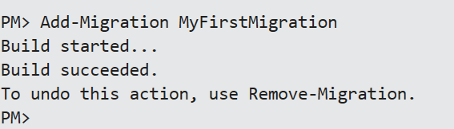

1. This command generates a code file in Visual Studio under a new folder called Migrations:

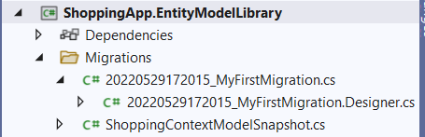

1. Open the MyFirstMigration.cs file and observe the generated code.
2. What is the usage of the Up and Down methods?
3. Which methods are provided by the **MigrationBuilder** class to create tables, columns, constraints, and indexes?
4. Note that the Add Migration command generates the code required to create the tables and DOES NOT generate the tables as such. To generate the tables, use the update command as shown below:

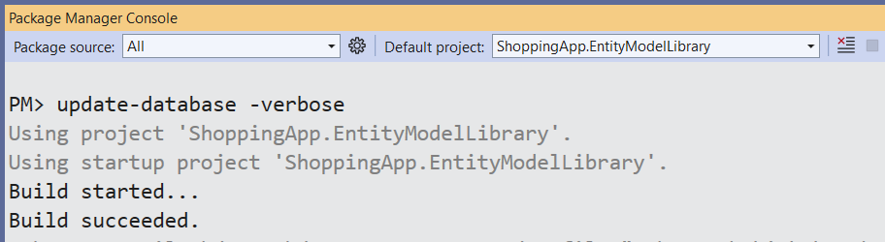

The verbose option will display the scripts generated to create tables from the classes. Read the scripts and understand the same.

1. Connect to SQL Server Management Studio and use the Object Explorer to check if the tables have been created in the Shoppe database.

